Exam 1 Name:_____________________________
Oct. 2, 2008 I agree to observe the Wake Forest
Chm 123 Honor Code during this exam.
75 minutes
100 points

Instructions: There are 15 questions and two bonus problems on the following pages. Check the exam now to be sure that you have all of these. There are two blank pages to be used as scratch paper at the end of the exam. You may remove these pages, as needed, but all answers must appear on the same page as the question and, where appropriate, in the designated space. The number of points for each question is given in bold following the question.

Write your name, clearly, in the space provided above.

Each question contains several parts. Be sure to completely read each question so that you answer all parts!

Answer each question as completely, but concisely, as possible.

Do not hesitate to ask a question if it arises.

Work in pencil.

Clearly answer each question - if your answer is unclear (or illegible), the problem will be counted wrong. You have 75 minutes to complete the exam. I advise that you work through the exam once answering what you know and save problems you are unsure of for the end of the period. Exams will be collected, promptly, 75 minutes after they are distributed. Do not attempt the bonus until you are satisfied with the rest of the exam. Little, if any, partial credit will be awarded on the bonus.

You are expected to abide by the Wake Forest University Honor Code and the rules of decency. Any violations of the Honor Code will be pursued through all necessary means.

Good luck.

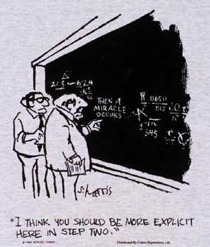

1. Draw Newman projections, looking down the indicated bond for the most stable and least stable conformations of this molecule. What is the relationship of the two structures you have drawn? Assign absolute configurations (R or S) to all chiral carbons. Name this compound according to IUPAC rules. In the space provided, draw the following: the enantiomer, one diastereomer, and one constitutional isomer. 18

IUPAC Name:

Most Stable Conformation Least Stable Conformation

Enantiomer Diastereomer

Constitutional Isomer
2. Indicate, in the space provided, if the pair of structures shown represents diastereomers (D), enantiomers (E), meso compounds (M), the same compound (S), or constitutional isomers (C). If the two molecules are not isomers of any kind, write an X on the blank. The pair may be both M and S. If this is the case, so indicate. 12

3. Draw a molecule that contains a carboxylic acid, an amine and an ether. The molecule must be realistic (i.e. correct number of bonds to the atoms and proper geometry). 5
4. Draw the following compound, (-)-menthol, in a chair conformation. Assign absolute configuration to the carbon bonded to oxygen. How many stereoisomers are possible for this structure? Draw the enantiomer of (-)-menthol in a chair conformation. Does (-)-menthol contain a more stable diastereomer? If so, draw it in its most stable chair. What functional groups are present in menthol? 15

5. (+)-9,10-Deoxytridachione is a polypropionate that can be isolated from several sea molluscs including Placobranchus ocellatus and Tridachia crispata. How many stereoisomers are possible for this molecule? Name the enantiomer of the molecule. You isolate a sample of deoxytridachione from a new mollusc and measure the rotation of plane polarized light to be -19.48°. What is the %ee of the mixture? What percentage of each enantiomer makes up the mixture you isolated? In the IR, you observe a band at 3028 cm⁻¹ and 1660 cm⁻¹. Assign each band to a part of the molecule. How would the IR change depending on whether you used a pure enantiomer or the mixture? Ocellapyrone and epi-deoxytridachione are related metabolites isolated from similar slugs; what is the isomeric relationship of these three compounds? 14

6. Which compound is responsible for the IR spectrum shown? Explain your choice. 10

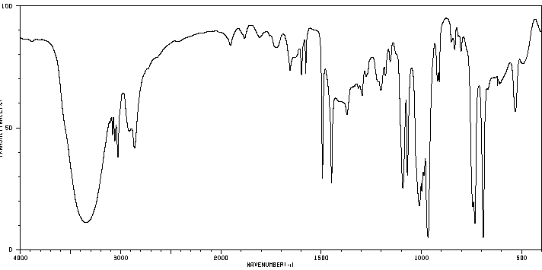

7. Give the products of the following acid/base reaction, identify the acid, base, conjugate acid and conjugate base and draw a mechanism for the observed proton transfer. Which side of the reaction is favored? 5

8. Draw a realistic and stable molecule with molecular formula C₇H₁₀O, two (and only two) sp hybridized carbons and one (and only one) sp² hybridized carbon. Identify the sp and sp² hybridized carbons. 3

9. How many π bonds are in the molecule you drew in 6? 2

10. How many π* molecular orbitals are in the molecule you drew in 6? 2

11. How many π* electrons are in the molecule you drew in 6? 2

12. Draw an example of a molecule that contains a trigonal planar carbon. 2

13. Draw an example of an organic compound that can participate in a hydrogen bond. 2

14. Circle all the molecules that would not absorb IR radiation. 3

15. A can be reduced to B by the reagent NaBH₄ dissolved in methanol. The product thus obtained (B) does not rotate plane polarized light. Explain. 5

Bonus 1 - 5 points

The IR spectrum for CD₃OD is shown below. How is this different from that you would expect for CH₃OH? How is it similar? Explain the physical reason behind the differences.

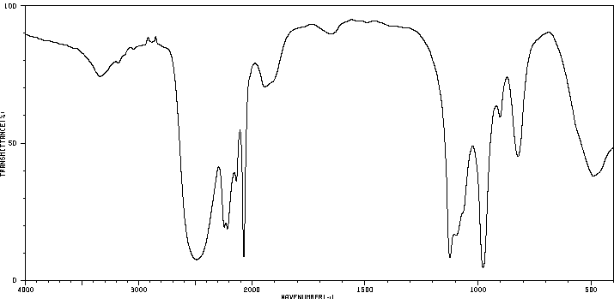

Bonus 2 - 5 points

Amidine is a significantly stronger base than ammonia (see pKa values given). Explain the physical reason.

